Creating a Panopto Recording in a General University Classroom (GUC)
Before creating your first recording, ensure Panopto is setup in your Canvas course space. The following steps will guide you through creating a Panopto recording in a General University Classroom (GUC).
- Login to canvas.wsu.edu and open your Canvas course space.
- Once in your course space, select Panopto Video from the left-hand course navigation menu.
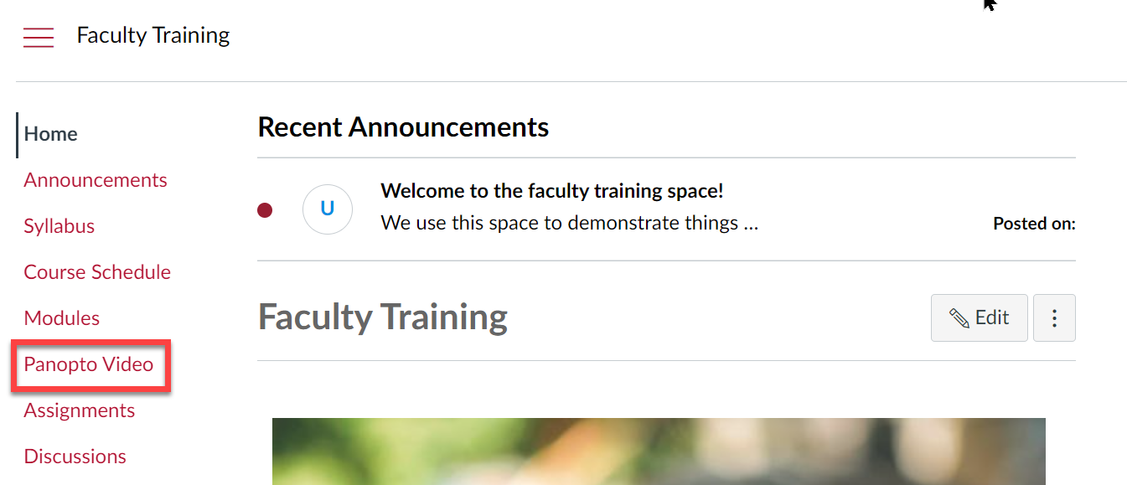

- At the top of the Panopto Video page, select the Create button.
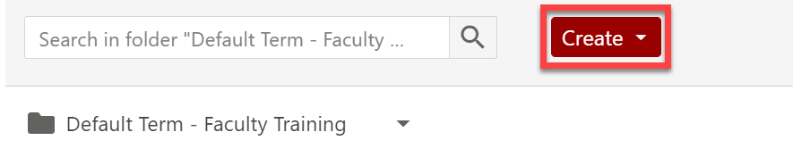

- From the Create dropdown menu, select Panopto for Windows.
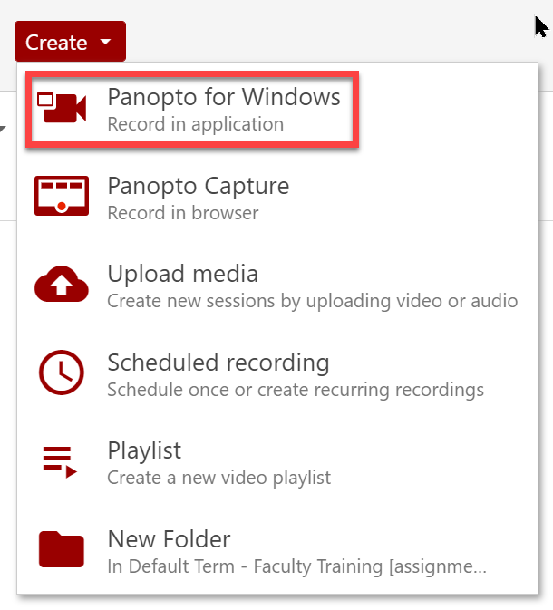
- In the Panopto for Windows pop-up window, select Launch Panopto
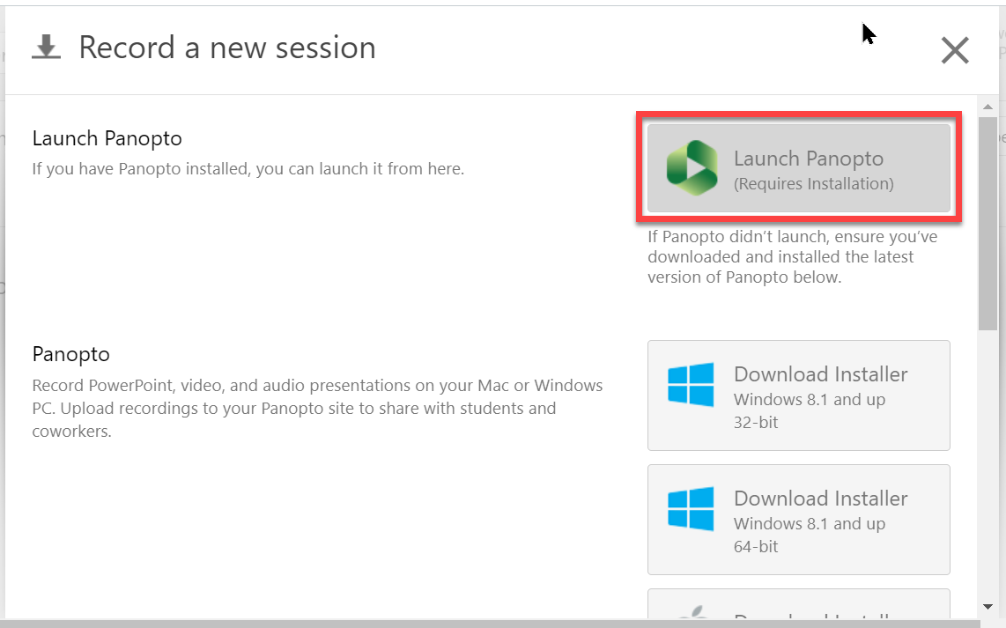

- In the next pop-up window, confirm Open Panopto Recorder.
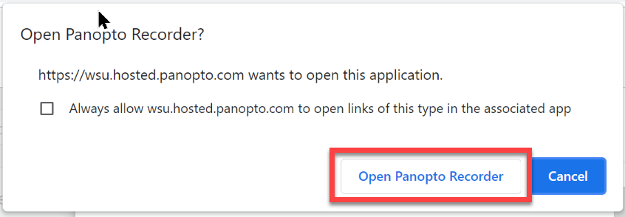
- Panopto Recorder Setting Options:
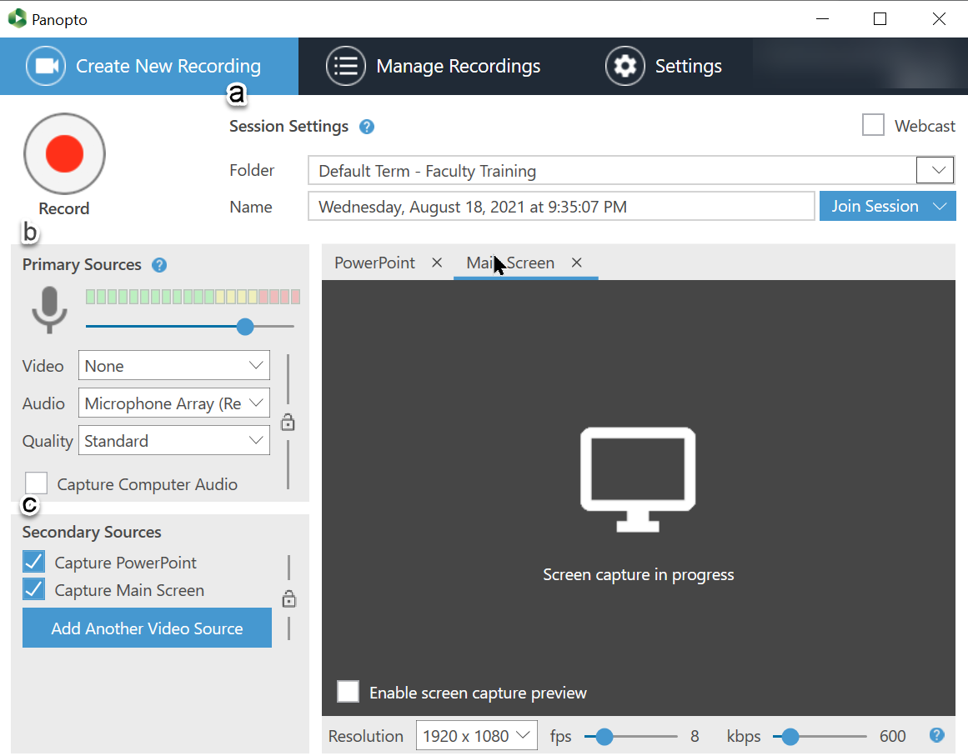

  - Under the section labeled ‘Sessions Settings’:
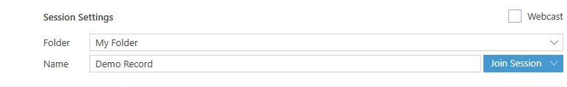
    - ‘Folder’: Ensure that your course video folder is selected. This folder is where the Panopto video will upload to. If the correct folder is not selected, choose the correct one from the dropdown list.
    - ‘Name’: Rename the session to something descriptive here or you can edit it later. Example: “Biology 100 – Exam Review”.
  - Under the section labeled ‘Primary Sources’ :
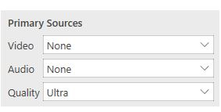
    - ‘Video’ and ‘Audio’: Select the correct video and audio sources from the dropdown menus.
      - Video: If you are using a camera, images register when the correct video source is selected.
      - Audio: Audio registers on the audio meter when the correct audio source is selected
      - Note: To locate the specific audio and video inputs for the GUC classroom you teach in, please visit the Classroom Specs website. Select your building and then room number and go to Panopto Settings.

    - ‘Quality’, select High or Ultra depending on your computer’s capabilities. Learn more at Panopto System Requirements (pdf).
  - Under the section labeled ‘Secondary Sources’:
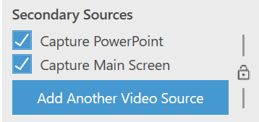
    - ‘Capture PowerPoint’ will record and index your slide presentation. Note: If you are recording a PowerPoint presentation, make sure this is checked.
    - ‘Capture Main Screen’ will record the computer you are working on. Note: Whatever you are doing on that computer will be recorded.
    - ‘Add Another Video Source’ if you are in a room with the ability to capture the document camera or laptop input (DVI2USB or VGA2USB or AV.io HDMI). You will see this in the Panopto video settings on your classroom specs webpage.
  - To record:
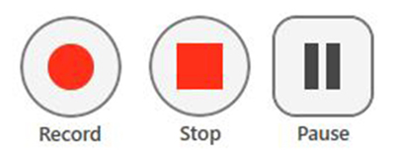
    - To start a recording, select the ‘Record’.
    - To stop a recording, select the ‘Stop’ button.
    - To pause a recording, select the ‘Pause’ button. Note: it is possible to resume the recording after it is paused.
- When you are finished recording, press the ‘stop’ button. You will be prompted to upload your recording. Select ‘Done’ to upload the recording to the video folder in your Canvas course space.
