MATH 142 – Pre Calculus II
Course Syllabus: Spring 2020

Instructor Information
Name: Dr. Professor J
Email: professorj@wsu.edu
Office Hours: Thursday from 9 am – 11 am
Course Information
- Class Times: MWF 2 pm – 3:25 pm
- Location: TBD
- Prerequisite: MATH 141 with a 2.0 or better within in the last three years; or appropriate placement score (SCC, SFCC)
- Text: Precalculus Concepts Through Functions A Unit Circle Approach to Trigonometry, Sullivan Sullivan 4th Edition
- MyLab Math: You will be given registration information in the event we use MyLab Math
Welcome to Math 142!
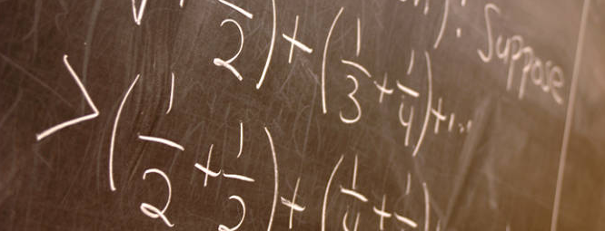

Precalculus is a wonderful medley of algebra and trigonometry designed to prepare students to enter Calculus. During this ten-week journey, we will learn about. Math is not a spectator sport! It is a relationship best developed through daily practice. You will be successful if you come to lecture, participate in lecture discussions/activities, complete your homework on time, and are able to verbally explain how you accomplished the homework problems. I am excited for this opportunity to guide you through the algebraic processes that this semester will bring!

Course Objectives
Do not allow the following course objectives to intimidate you. Consider it a checklist that I will be using to make sure you are properly prepared for Calculus. You can also use it as a checklist for yourself. If, when reading it, you cannot visualize the processes described, please reach out to myself or a peer and get understanding. This course and all the information presented, is yours for the taking.

Upon successful completion of Math 142, student should be able to:
1. Utilize the trigonometric functions and the inverse trigonometric functions and their properties.
* Solve trigonometric equations and applications
--Graph the trigonometric functions and transformations
Apply vectors in two-space
2. Solve parametric equations and polar coordinates
3. Use sequence and summation notation
4. Recognize conic sections

Grading System
Lorem ipsum dolor sit amet, consectetur adipiscing elit. Maecenas scelerisque, eros eget fringilla cursus, diam enim egestas dui, sit amet fringilla lectus dui vitae massa. In vestibulum ut lorem ullamcorper scelerisque. In blandit mauris eu condimentum ullamcorper. Phasellus sit amet diam efficitur, vehicula purus vitae, semper nibh. Nullam mattis,
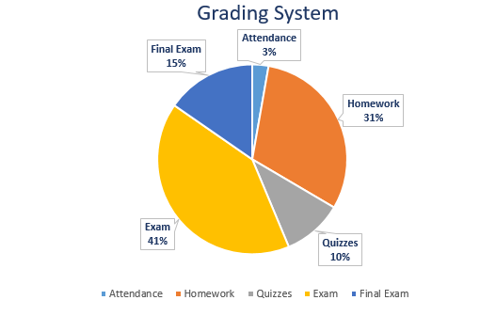

mi quis congue venenatis, nisl orci pretium erat, at gravida diam lorem egestas urna. Sed egestas elit sit amet commodo laoreet. Nullam nibh purus, fermentum efficitur elit vel, viverra pulvinar nibh. Duis congue nisl enim, quis interdum nisi suscipit at. Nam at cursus velit. Quisque auctor mollis mauris eu tincidunt. Aliquam non nisi dictum, maximus metus quis, mollis sapien. Sed bibendum luctus erat eu bibendum. Morbi vestibulum velit ut mi luctus rhoncus.

Component | Points
Attendance | 27
Homework (4) | 300
Quizzes (10) | 100
Exam (4) | 400
Final Exam | 150

A | 977 - 918
A- | 917.9 - 879
B+ | 878.9 - 850
B | 849.9 - 811
B- | 810.9 - 782
C+ | 781.9 - 752
C | 751.9 - 713
C- | 712.9 - 684
D | ≤ 684

Late Work Policy
Work submitted after the due date will be subject to a penalty of up to 10% per day late. If you have a verifiable reason for missing a deadline, please contact the instructor privately.

Attendance
You are expected to come to each class meeting. In class work, extra credit possibilities and quizzes that are missed due to absence cannot be made up. Please review the course schedule. In the event I am absent, understand that

- A video lecture will be provided. Always follow the course schedule as this is how you can stay (and I can stay) on track. The course schedule is subject to be updated to reflect any and all unforeseen changes in how the course will progress.
- Homework is still due if I am gone and you will be given instructions on how to submit it.

If you must be absent because of an emergency or illness, please make every effort to speak with me about it beforehand, if possible, or after the next class. I will excuse such absences with a doctor’s note or other form of official documentation. Keep in mind that more than two unexcused absences will negatively affect your final grade.

Assignments
Homework details (practice problems and due dates) can be found on the course schedule. In the event that you know you will be absent, you may hand your homework in early – not late. (Do not hand in early homework if you plan to be in class). Expectations regarding your homework submissions are as follows:

- All work is handwritten (unless submitting through MyLab Math)
- Homework will be legible and neat if hand-written (include name and homework number in top right corner).
- Some questions require a simple answer while other problems require solutions. Solutions may include but are not limited to, neatly drawn graphs, several sentences, a page length of calculations, and so on and so forth
- In all of your responses to any math problem, show how you derived the answer. Your work must be your own.

Academic Integrity
Academic integrity is the cornerstone of higher education. As such, all members of the university community share responsibility for maintaining and promoting the principles of integrity in all activities, including academic integrity and honest scholarship. Academic integrity will be strongly enforced in this course. Violation of WSU’s Academic Integrity Policy (identified in Washington Administrative Code (WAC) 504-26-010(3) and -404) may result in penalties up to and including failing the assignment, exam, quiz, course requirement, or the course itself and students will not have the option to withdraw from the course pending an appeal, and will be reported to the Office of Community Standards.

Cheating includes, but is not limited to, plagiarism and unauthorized collaboration as defined in the Standards of Conduct for Students, WAC 504-26-010(3): http://app.leg.wa.gov/WAC/default.aspx?cite=504-26-010 . If you have any questions about what is and is not allowed in this course, you should ask course instructors before proceeding. Read More

If you wish to appeal a faculty member's decision relating to academic integrity, please use the form available at https://communitystandards.wsu.edu/ .

Copyright
Any course-related materials, presentations, lectures, etc. are the instructor's intellectual property and may be protected by copyright. The use of University electronic resources for commercial purposes, including advertising to other students to buy notes, is a violation of WSU's computer abuses and theft policy (WAC 504-26-218). Selling class notes through commercial note taking services without written advance permission from the faculty, could be viewed as be as copyright infringement and/or academic integrity violation, WAC 504-26-010 (3)(a,b,c,i).

Academic Regulations
Students enrolled in online courses are subject to the same University academic regulations as on-campus students. For the most accurate and up to date information go to http://registrar.wsu.edu/academic-regulations/.

Math 142: Winter 2020 Tentative Course Schedule – Subject to Change
Weeks and Dates | Lesson | Assignments | Due Date by 11:59pm Pacific Time  unless otherwise noted
Unit 1
1 - Jan. 6 - 10 | Lessons 1-2 | HW1 (Due Fri., Jan 17) | Possible Quizzes
Unit 2
2  Jan. 13 - 17 | Lessons 3-5 | Discussion: Equations | Original Post: Jan. 29 (Wed)  Paper Draft: Jan. 30 (Thurs)  Exam 1: Fri., Jan 17
 |  | Paper 1 Draft
 |  | Exam 1 on Chapter 5
Unit 3
3  Jan. 20 – 24  (Holiday Mon., Jan 20) | Lessons 6-8 | HW2: (Due Wed., Feb 5) | Possible Quiz
Unit 4
4  Jan 27 - 31 | Lessons 9-11 | HW2 (Cont.) | Possible Quizzes
Unit 5
5  Feb. 3 - 7 | Lesson 12 | HW2 (Cont.) | Exam 2 on Chapter 6 (Due Wed., Feb. 5)

