Viewing a Panopto Recordings
Students can access the instructor’s recording through their Blackboard course space. The following steps will guide you through:
- Go to learn.wsu.edu and log in to your Blackboard course space (Note: Safari browser is currently not supported for viewing)
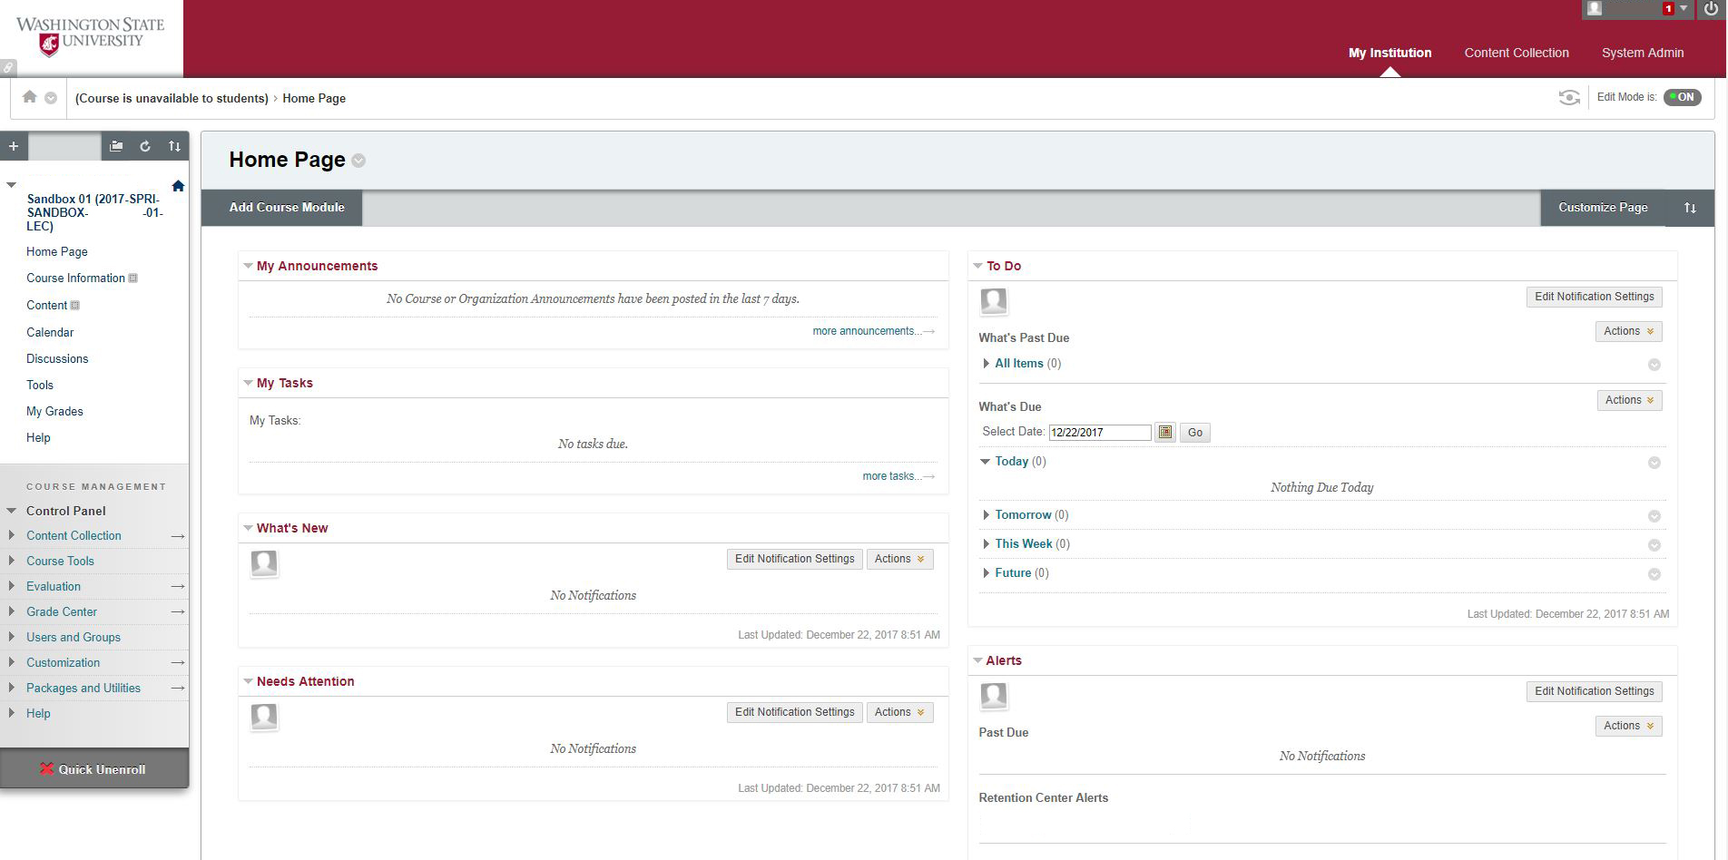
- Once in your Blackboard course, select ‘Tools’ from the sidebar menu
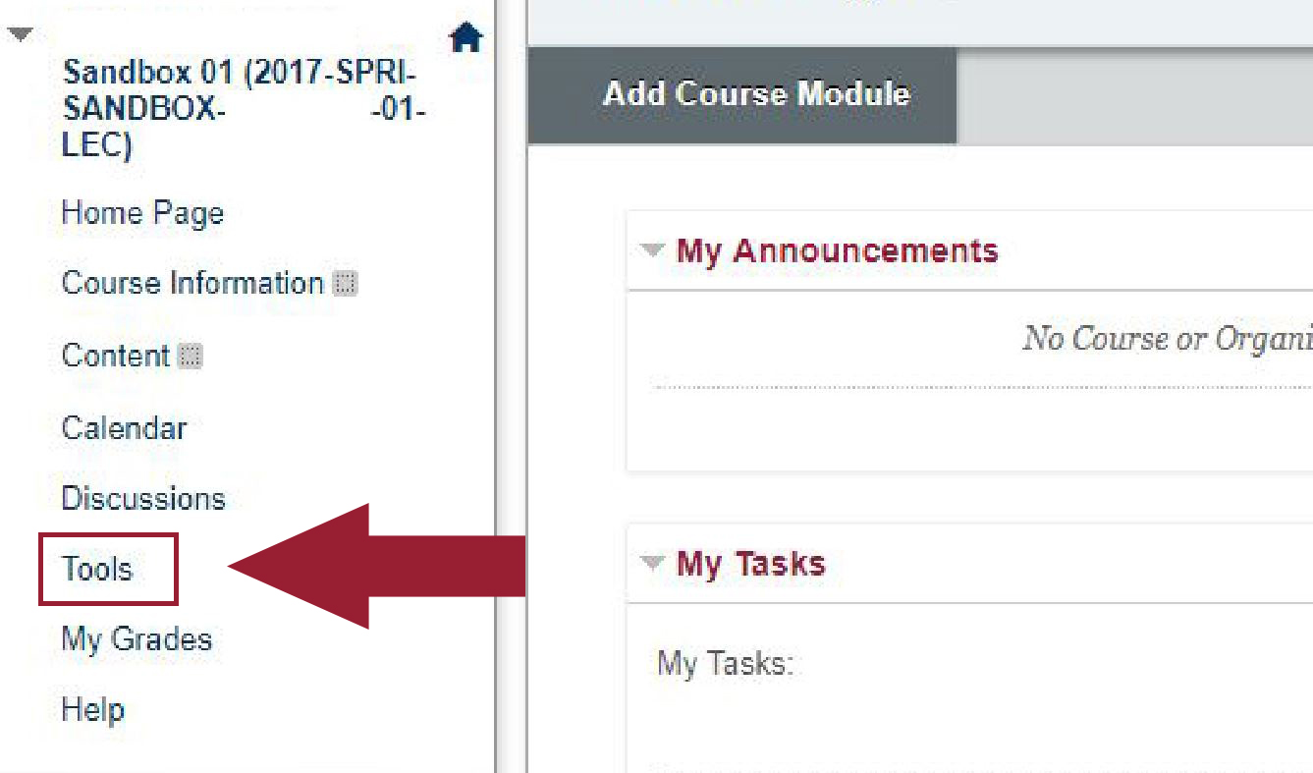
- In the ‘Tools’ section, select the ‘Panopto Content’ link (located 5th link down the page, in the right-hand column)

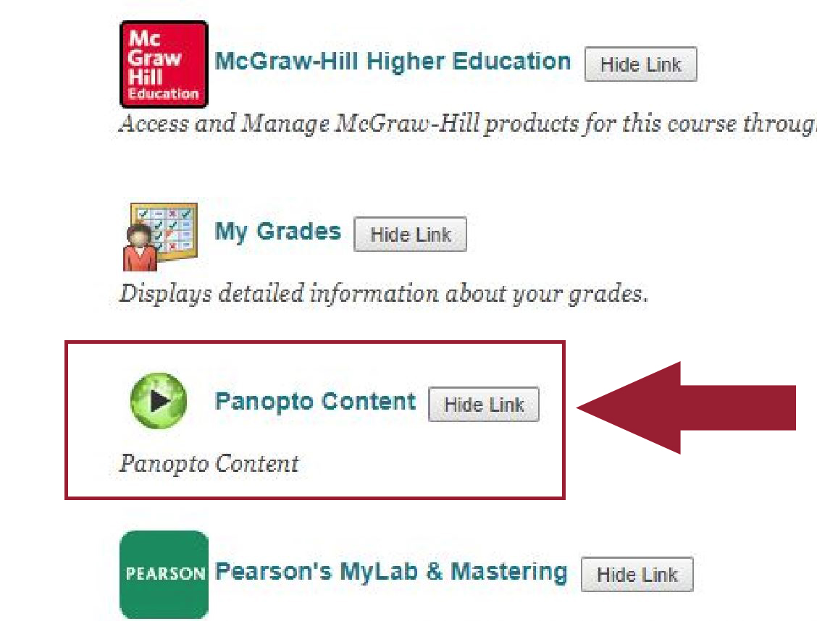
- The ‘Panopto Content’ link will take you to your course Panopto video folder where you can select the Panopto video to view.

