Create a Panopto Recording (Mac)
Mac specific instructions for downloading the Panopto recorder and creating and uploading a recording to your course space:
- Go to learn.wsu.edu (using either Chrome or FireFox) and log in to your Blackboard course space
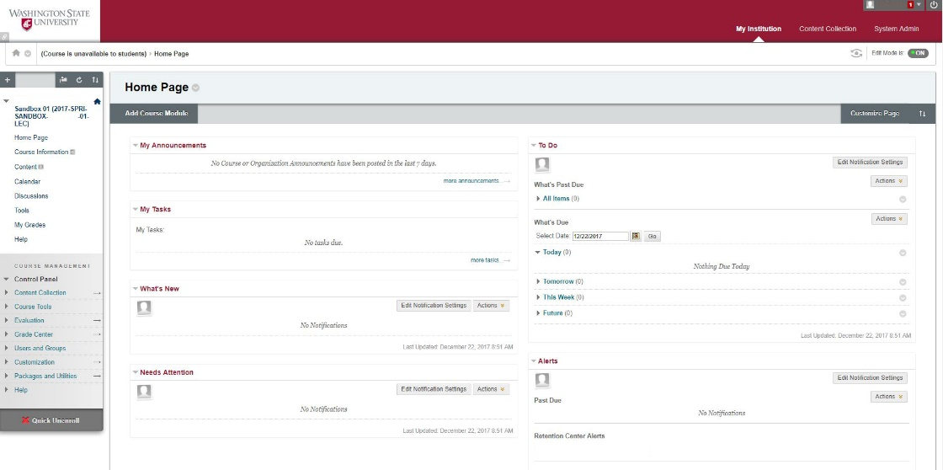
- Once in your Blackboard course, select ‘Tools’ from the sidebar menu
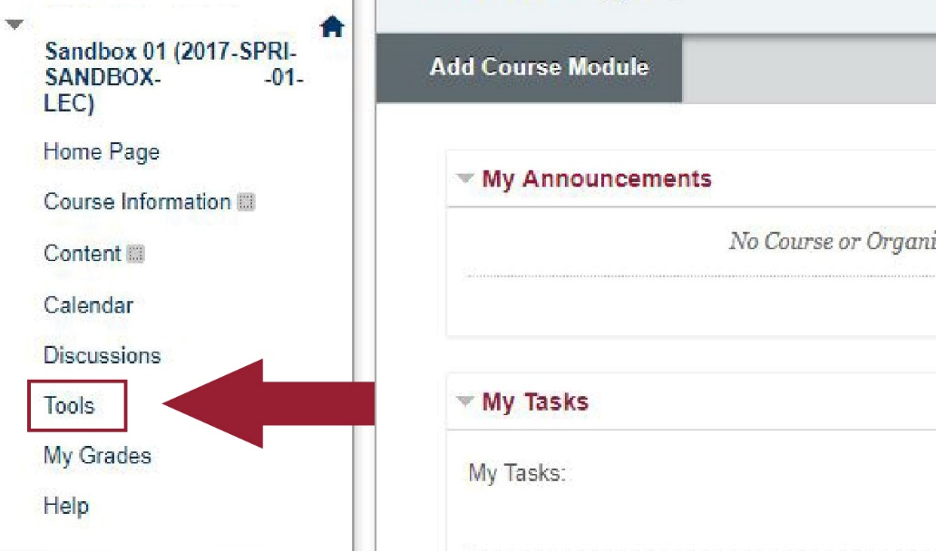

- In the ‘Tools’ section, select the ‘Panopto Content’ link (located 5th link down the page, in the right-hand column)
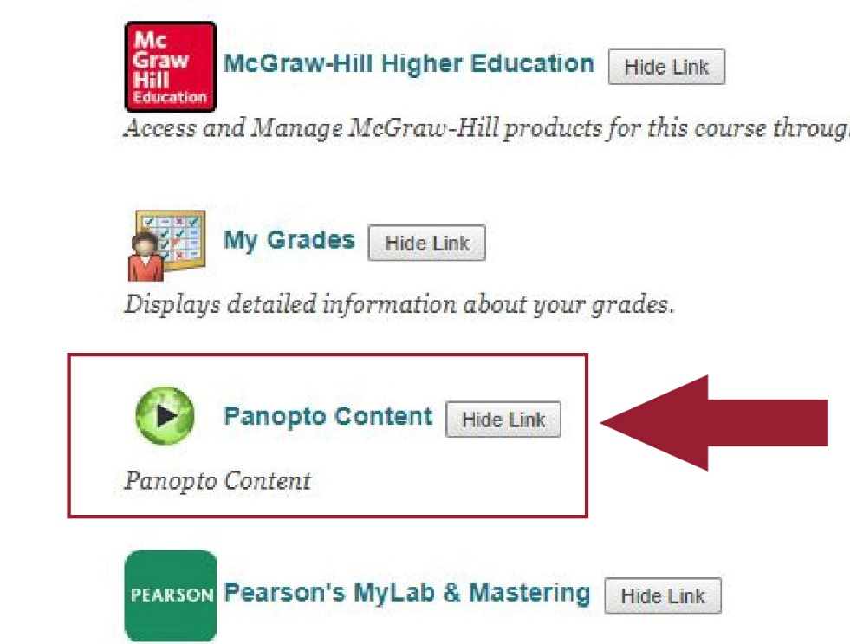
- The ‘Panopto Content’ link will take you to your course Panopto video folder. (If you do not already have a Panopto video folder created for your course, please see Set Up Panopto in Blackboard)

- In the Panopto video folder, select the ‘Create’ button (located at the top of the page) and a drop down menu will appear.
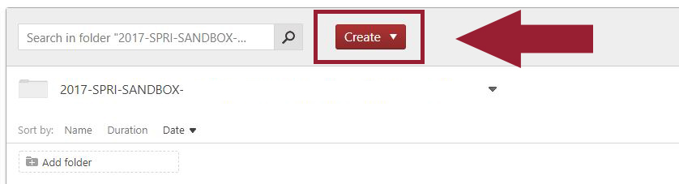

- From the dropdown menu, select ‘Record a new session’
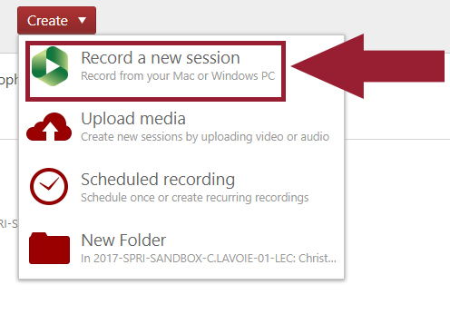
- A popup menu will appear confirming your choice to open the Panopto recorder. Select ‘Open Panopto Recorder’, the recorder will open and automatically log in with your Blackboard credentials.

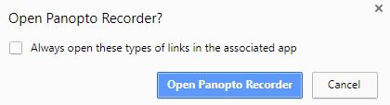
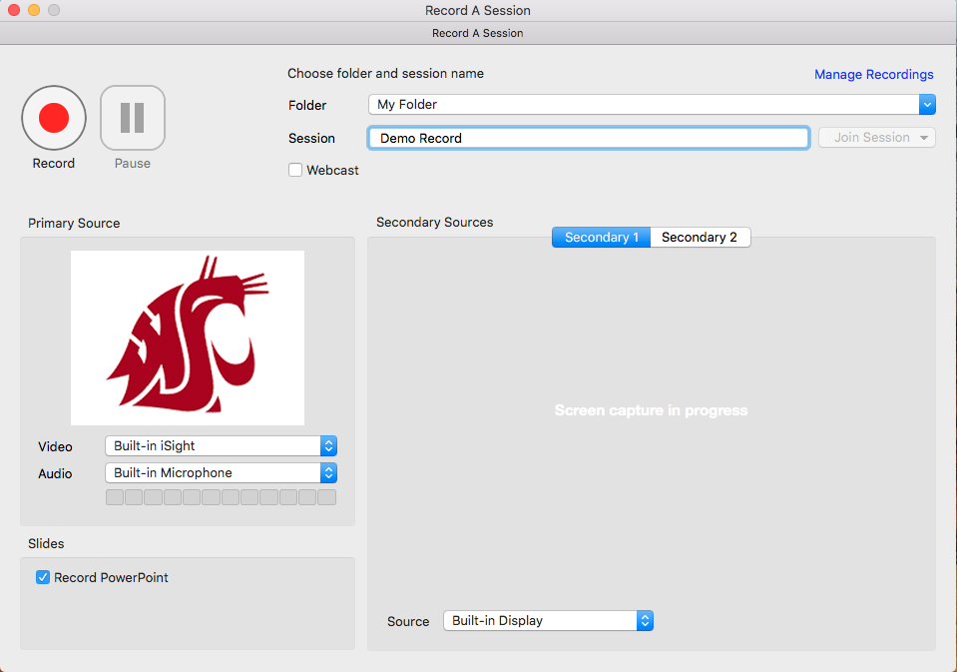
  - If you do not already have the Panopto recorder installed on the computer, select ‘Download Installer OS X 10.10 and up’ and follow the instructions to install the application
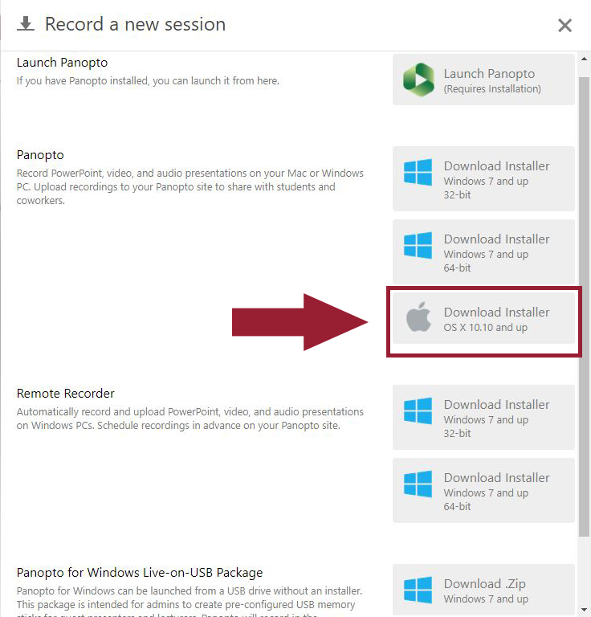

- Panopto Recorder Setting Options:
  - Under the section labeled ‘Choose folder and session name’:
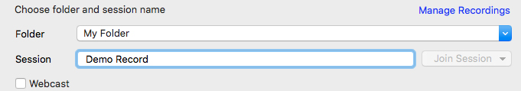
    - ‘Folder’, ensure that your course video folder is selected. If the correct folder is not selected, choose the correct one from the drop down list.
    - ‘Session’, rename the session to something descriptive. Example: “Biology 100 – Exam Review”

  - Under the section labeled ‘Primary Sources’ :
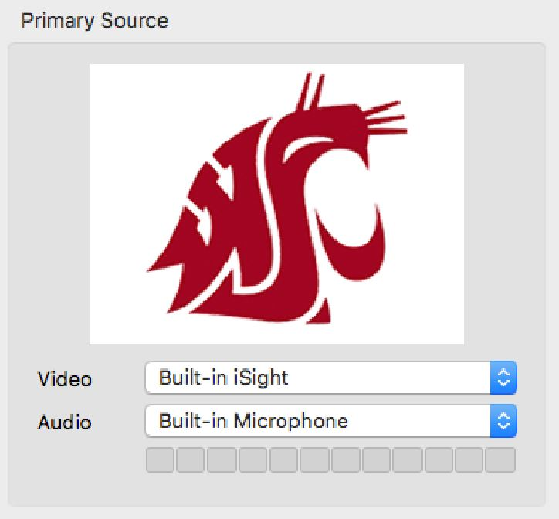
    - ‘Video’ and ‘Audio’, select the correct video and audio sources from the drop down menus.
      - Video: If you are using a camera, you will see it appear when the correct video source is selected.
      - Audio: You will see audio on the audio meter when the correct audio source is selected.
  - Under the section labeled ‘Slides’:
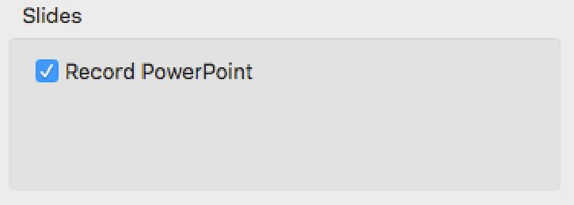
    - ‘Record PowerPoint’ will record and index your slide presentation. If you are recording a PowerPoint presentation, make sure this is checked.
  - Under the section labeled ‘Secondary Sources’:
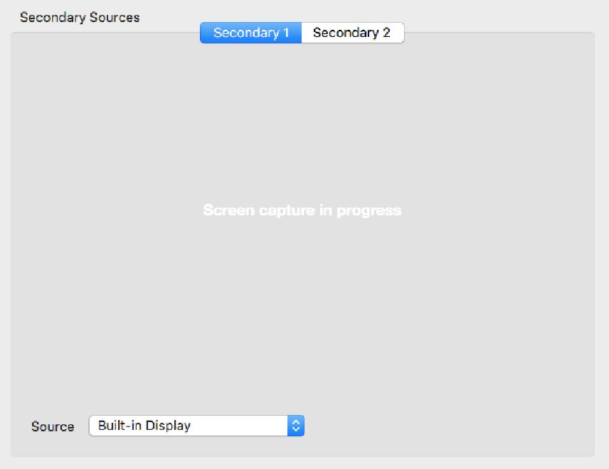
    - ‘Secondary Source 1’ and ‘Secondary Source 2’ will allow you to choose and record available sources from a drop down menu. Note: If you select the computer you are working on as a source, whatever you are doing on the computer will be recorded.
  - To record:
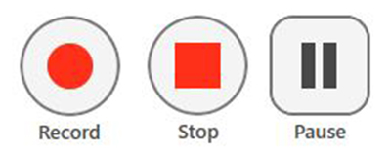
    - To start a recording, select the ‘Record’ button.
    - To stop a recording, select the ‘Stop’ button
    - To pause a recording, select the ‘Pause’ button. Note: it is possible to resume the recording after it is paused.

- When you are finished recording, press the ‘stop’ button, you will be prompted to upload your recording. Select ‘Upload’ to upload the recording to the video folder in your Blackboard course space. Students will access your recording through the video folder following steps 1-4.
