Setup Panopto in Blackboard
Before you can upload Panopto content to Blackboard, you must setup a video folder that is linked to your course space. The following steps will guide you through the process:
- Go to learn.wsu.edu (using either Chrome or FireFox) and log in to your Blackboard course space
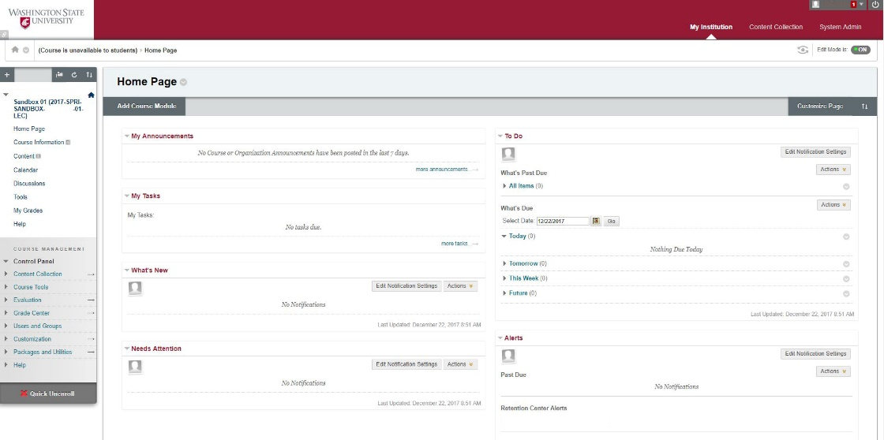
- Once in your Blackboard course, select ‘Tools’ from the sidebar menu
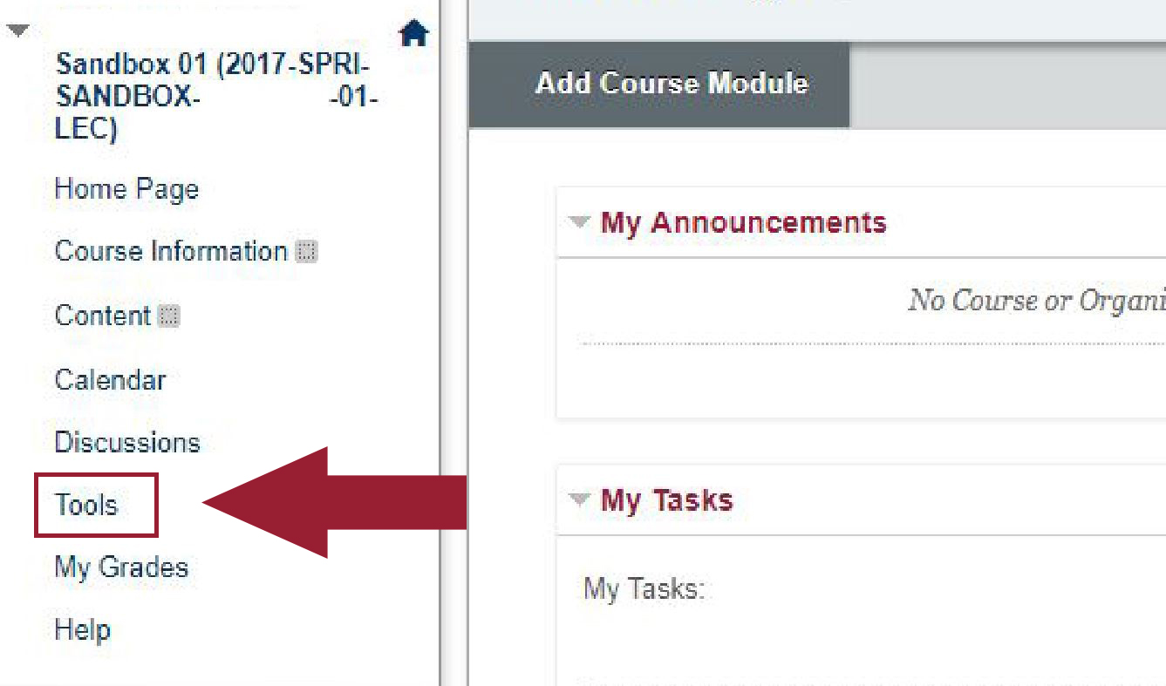

- In the ‘Tools’ section, select the ‘Panopto Content’ link (located 5th link down the page, in the right-hand column)
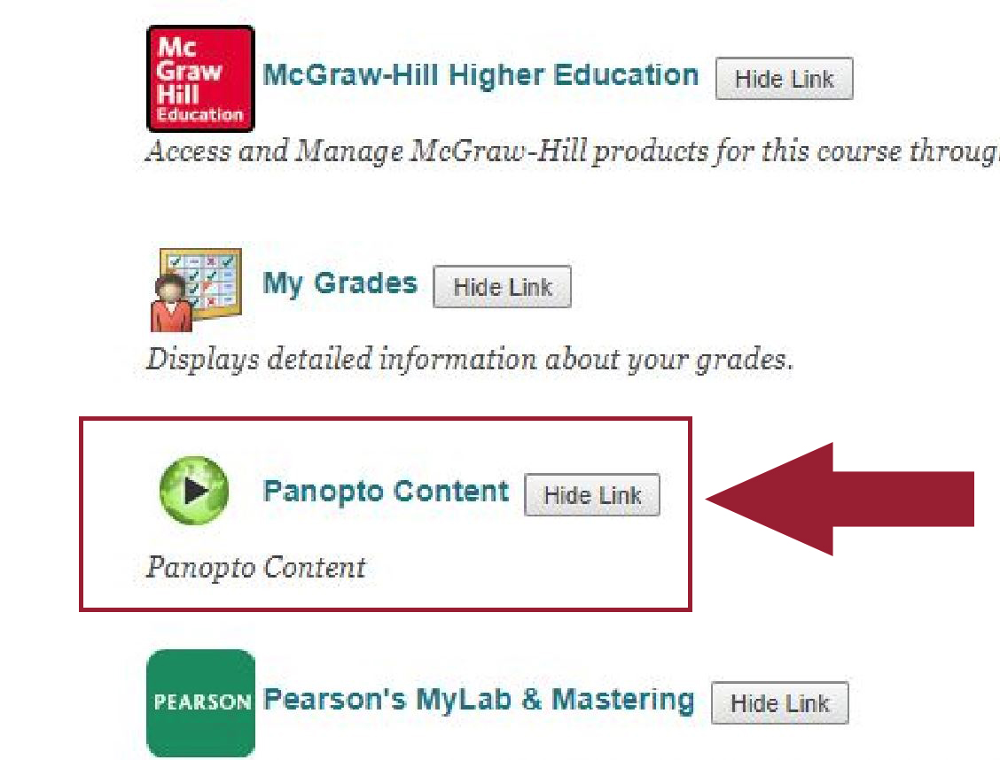
- To create (provision) a Panopto video folder, select the ‘configure’ button.
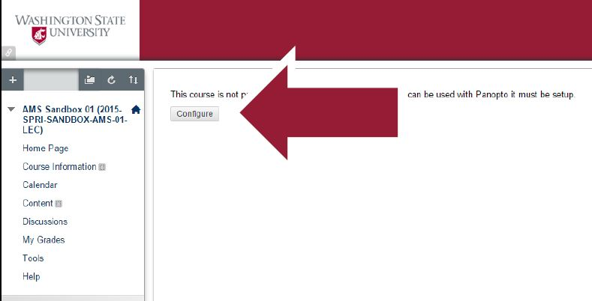
- Select the ‘Add course to Panopto’ button
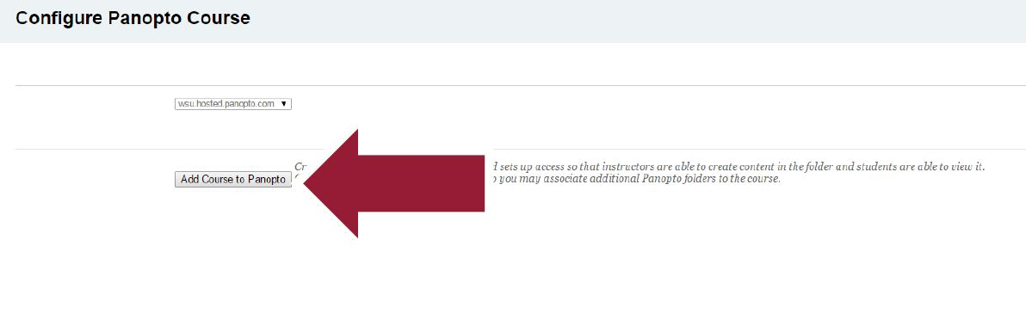
- Select the ‘OK’ button
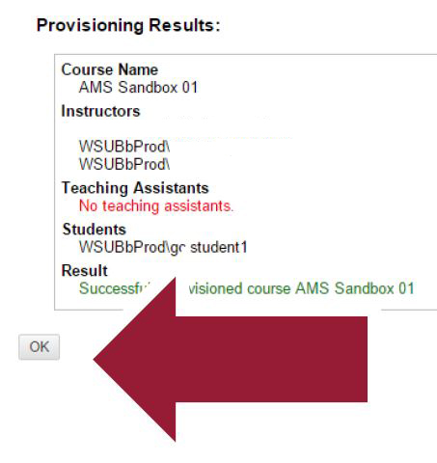
- Under ‘Selected Folders’, ensure that the correct folder (with your course name and SLN) is selected.

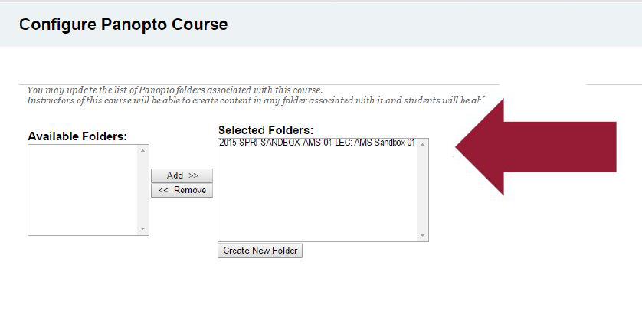
- Select the ‘Submit’ button

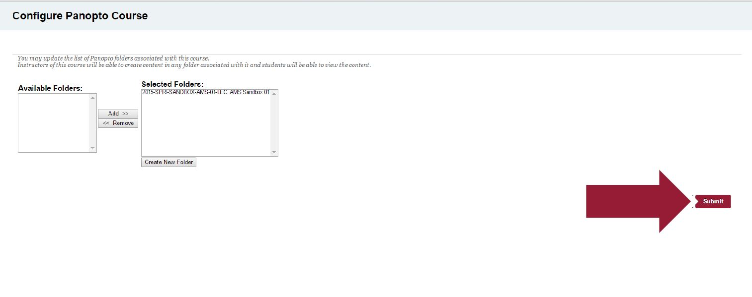
- You will be taken to your newly created Panopto folder and can begin recording and uploading videos to your course space. All students enrolled in your class will be able to view videos in this folder as well.
