Create a Panopto Shortcut in Blackboard
Creating a Panopto tool link makes viewing uploaded videos just one click away for you and your students. The following steps will guide you through the process:

- Go to learn.wsu.edu and log in to your Blackboard course space.

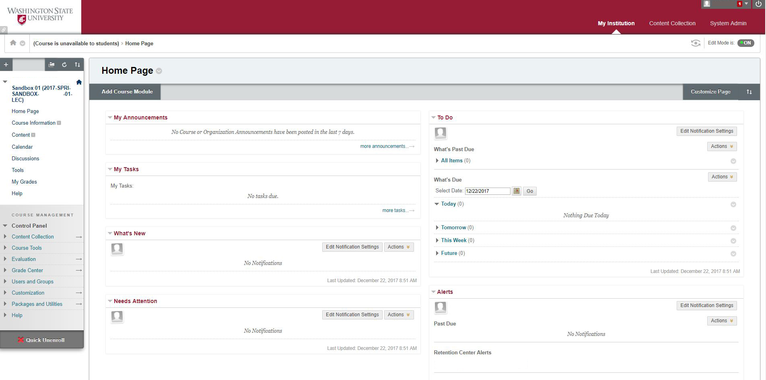

2. Once in your course space, select the plus icon located in the upper left corner of the sidebar.

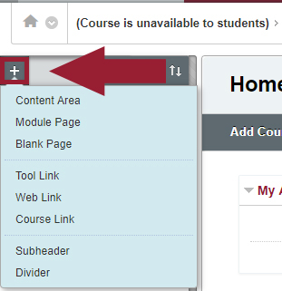

3. When the plus icon is selected, you will see a dropdown menu.

4. From the dropdown menu, select the ‘Tool Link’ (fourth selection down)

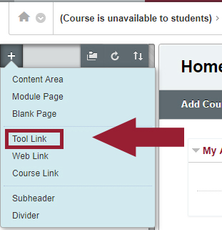
5. In the ‘Add Tool Link’ popup:
Name: Create a name for the link (ex: Panopto or Panopto Videos)
Type: Select ‘Panopto Course Tool Application’ from the dropdown menu
Check the box ‘Make Available to Users’

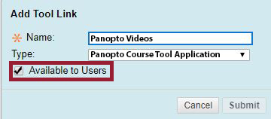

6. Select ‘Submit’

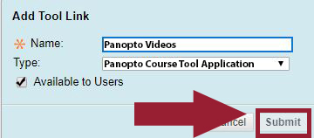

7. You will see the Panopto shortcut link you just created in the sidebar menu. When you click on the link it will take you directly to your Panopto video content. Your students can use this link as well.

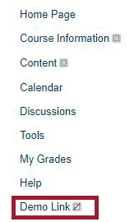

8. Change the order the link appears in the sidebar by holding down the arrow icon (located to the left of the link) and drag to the desired position.

